**Project 4 – CIS 400**

**Scheme Language**

[**https://replit.com/@zeinabsabra2022/CurlyMedicalBlogclient#main.scm**](https://replit.com/@zeinabsabra2022/CurlyMedicalBlogclient#main.scm)

**Task 1:**

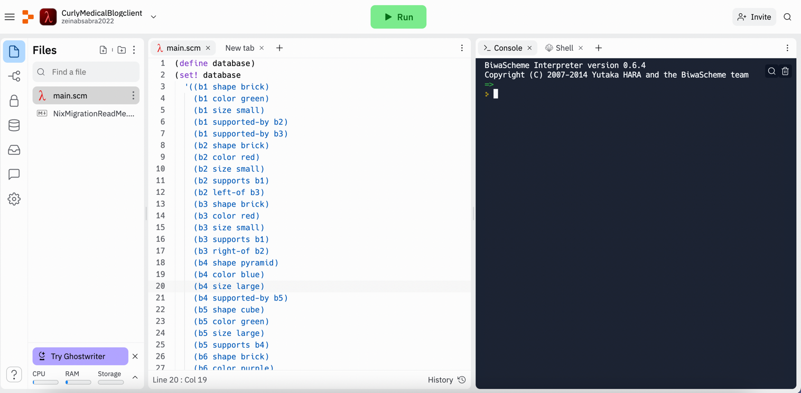

**Task 2:**

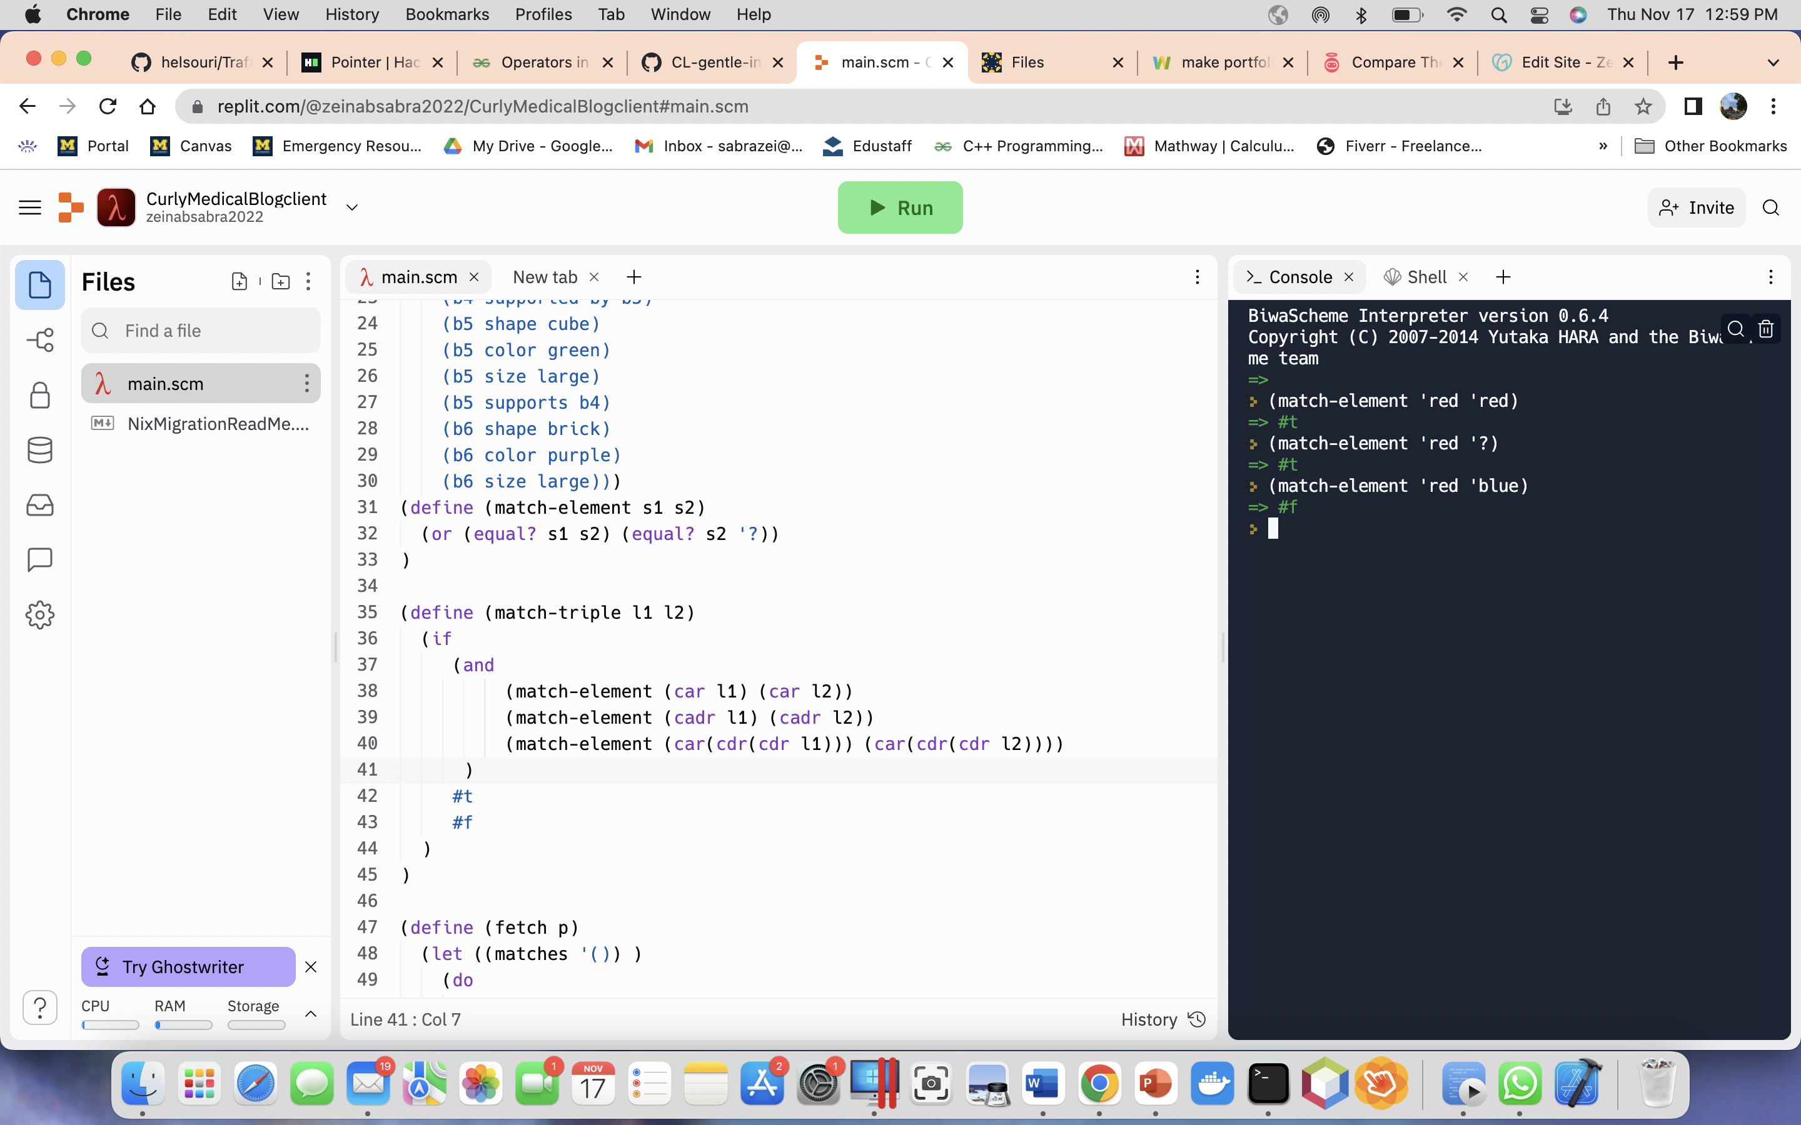

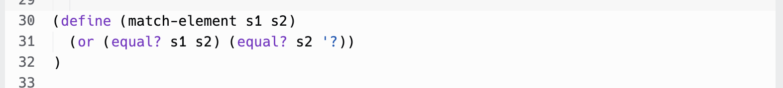

**Task 3:**

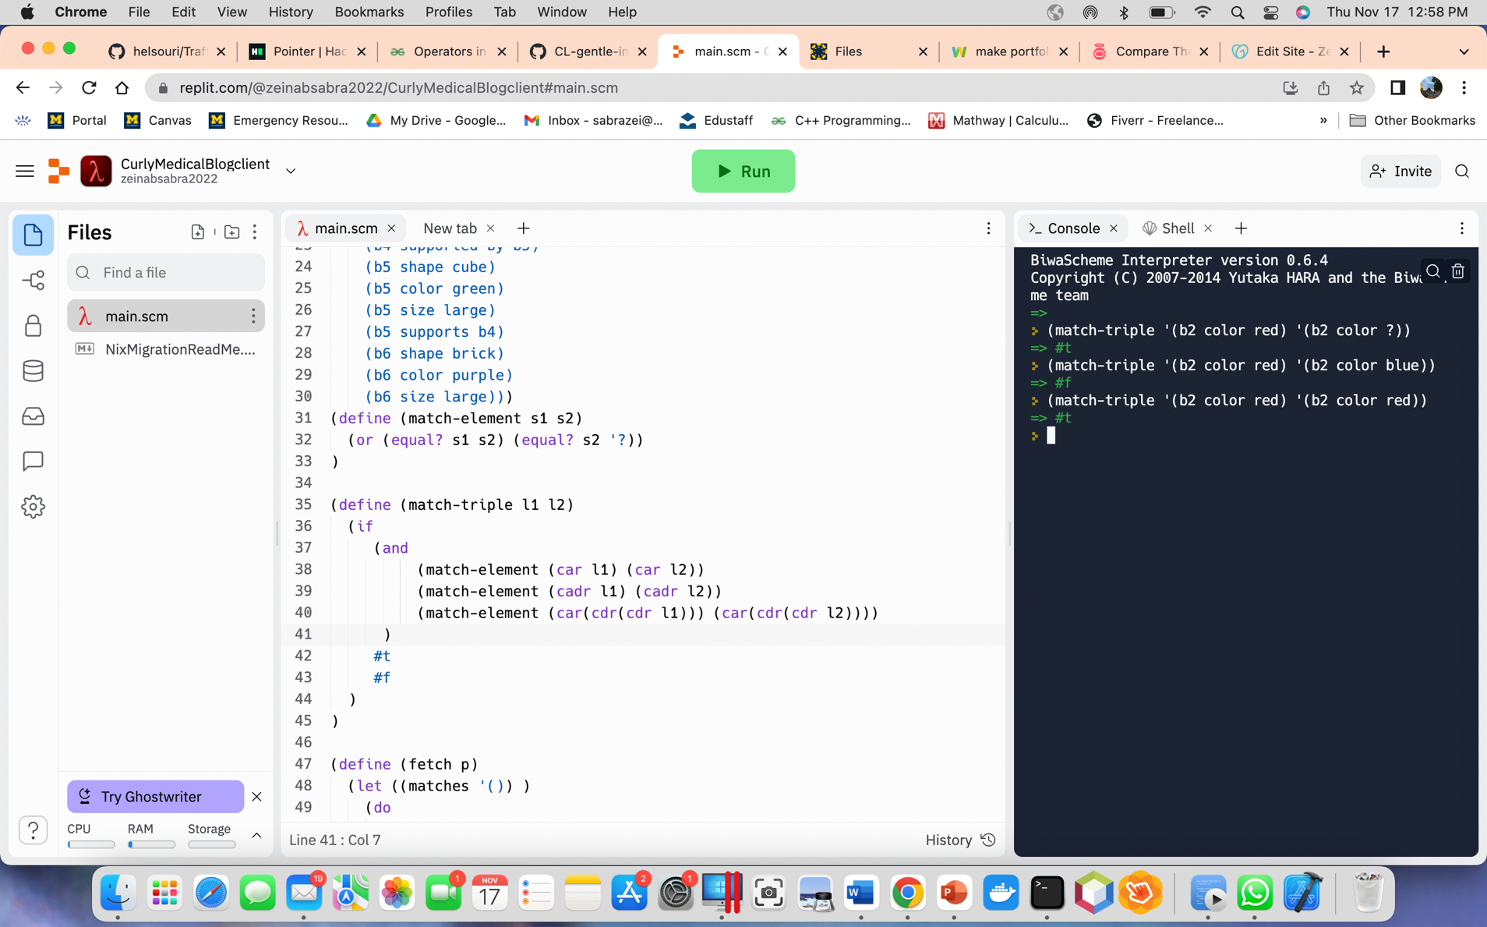

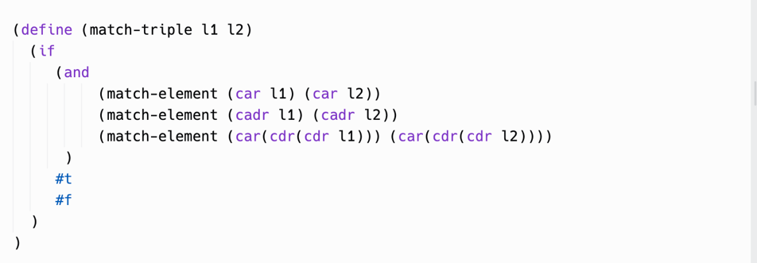

**Task 4:**

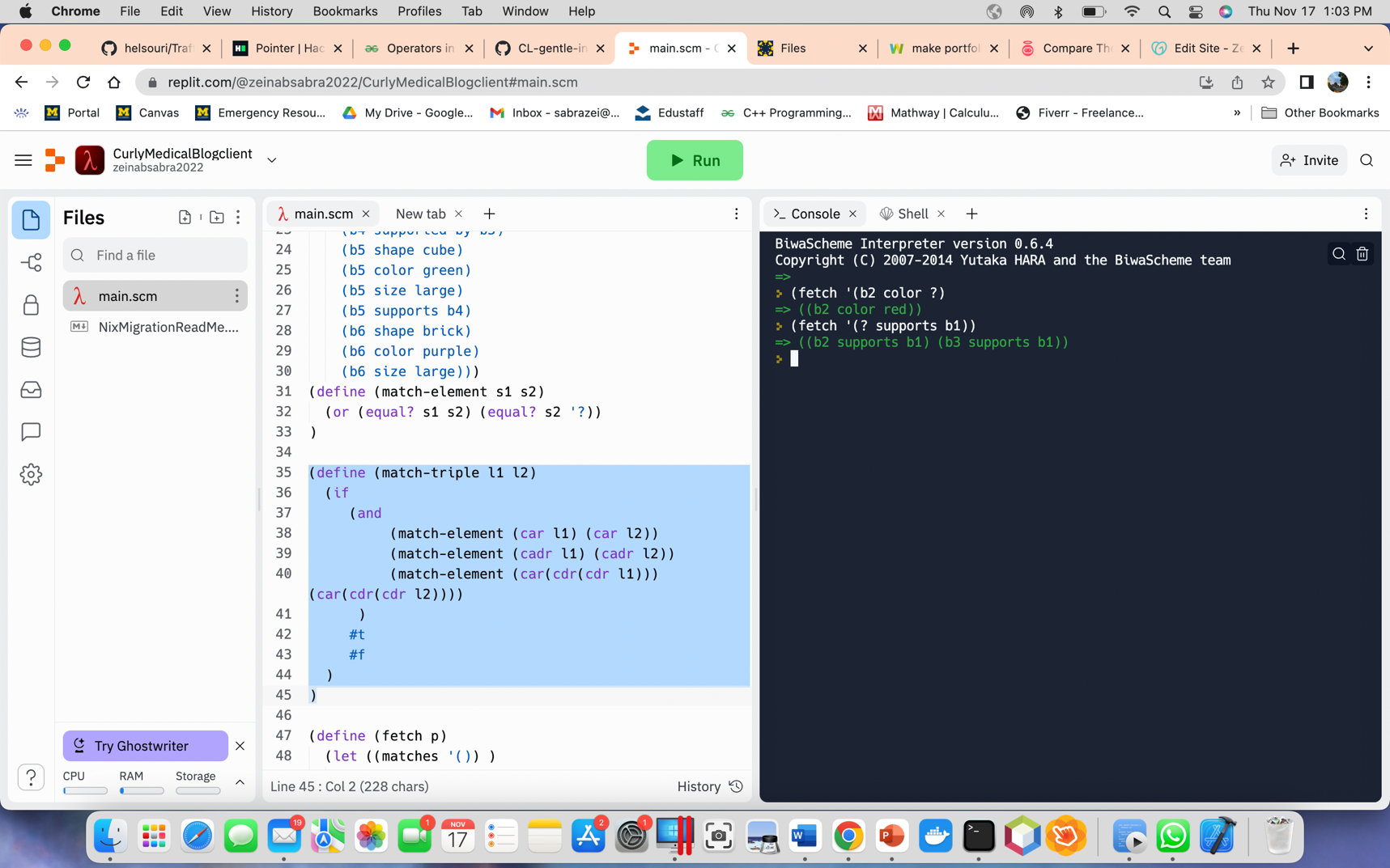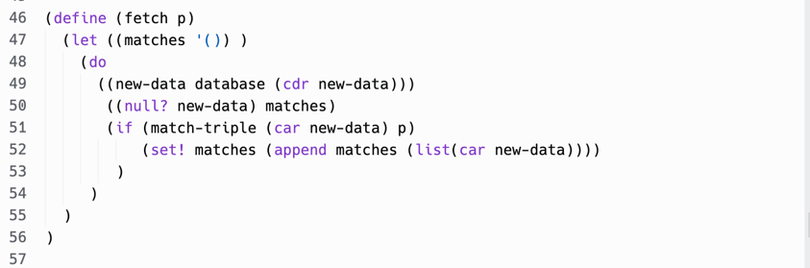

**Task 5:**

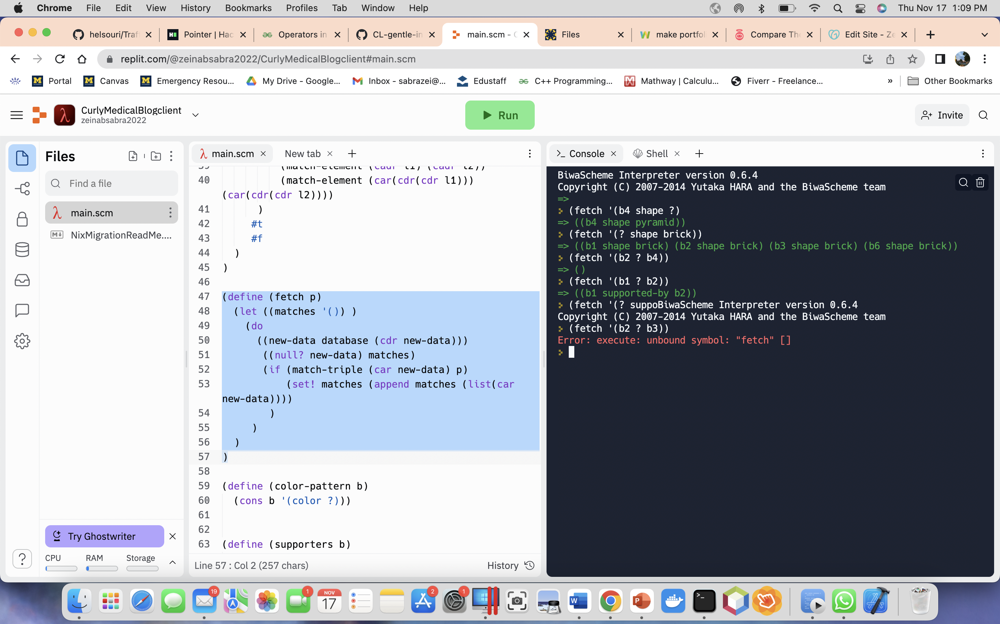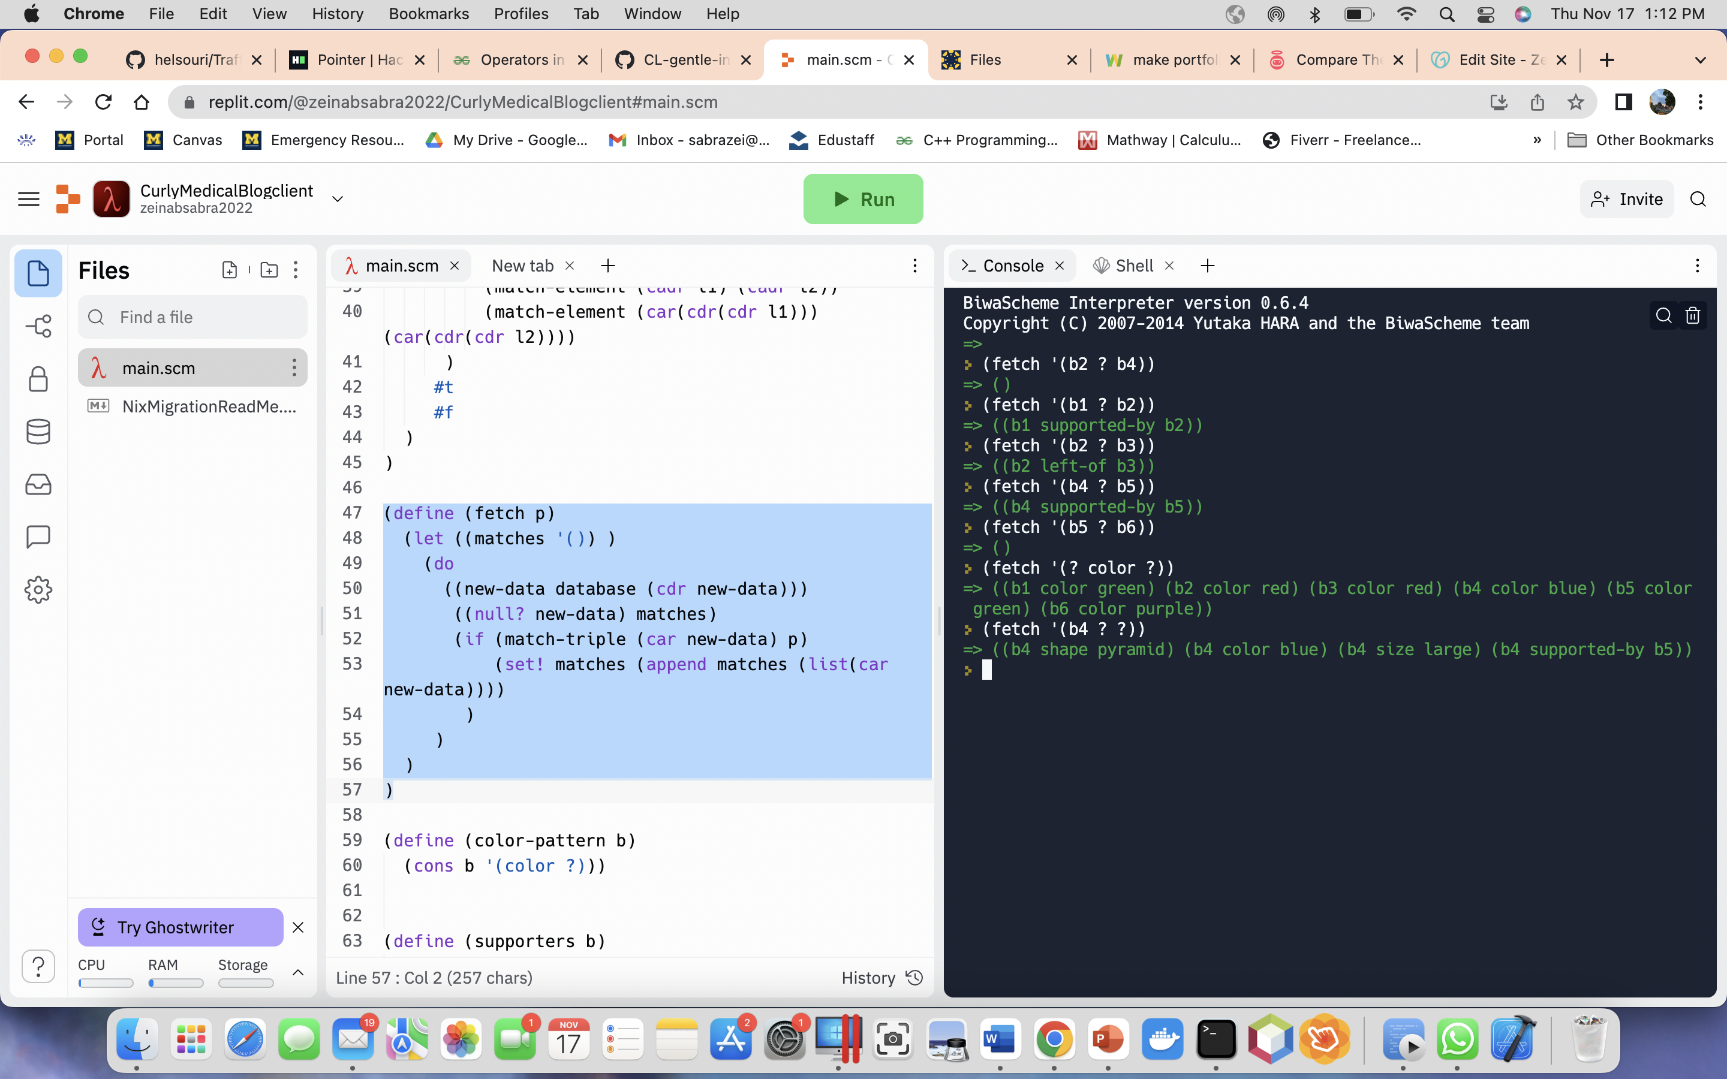

**Task 6:**

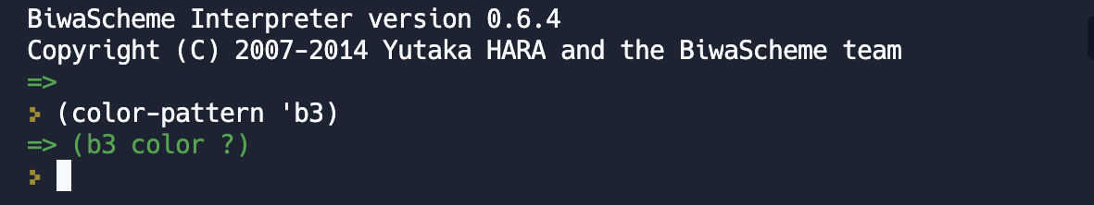



**Task 7:**

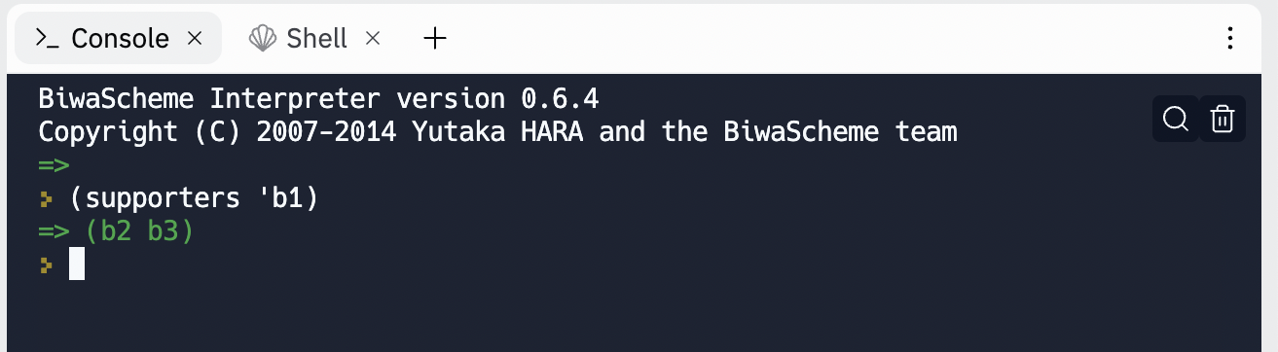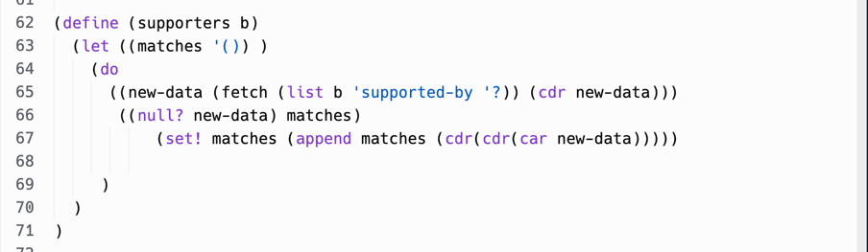

**Task 8:**

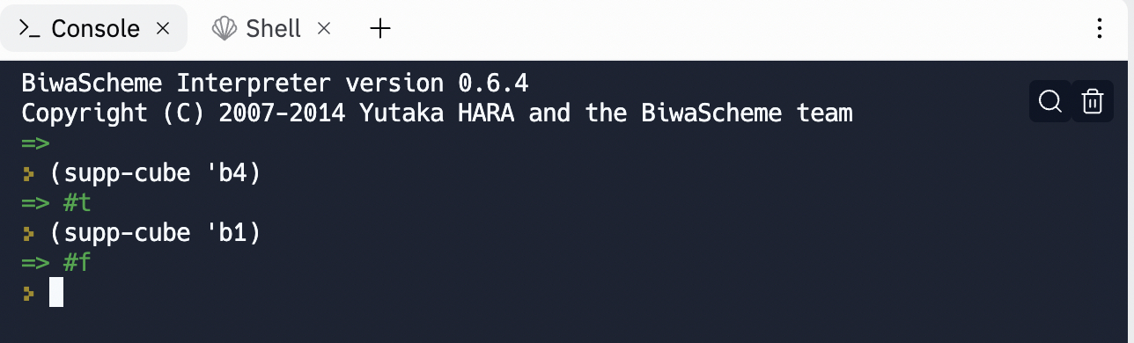

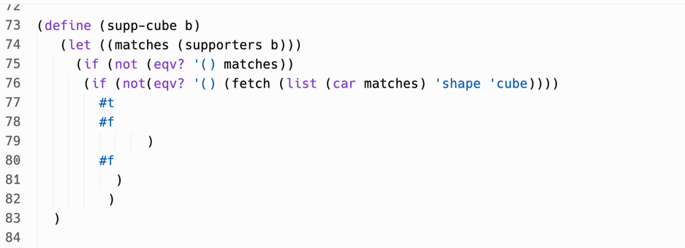

**Task 9:**

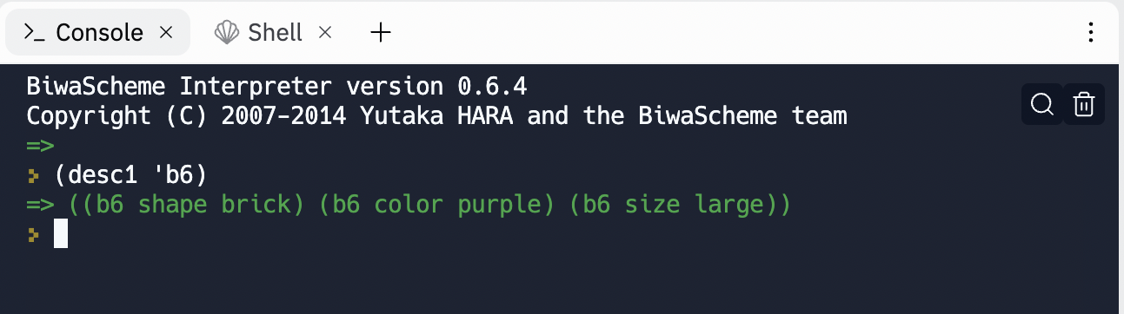**Part a:**

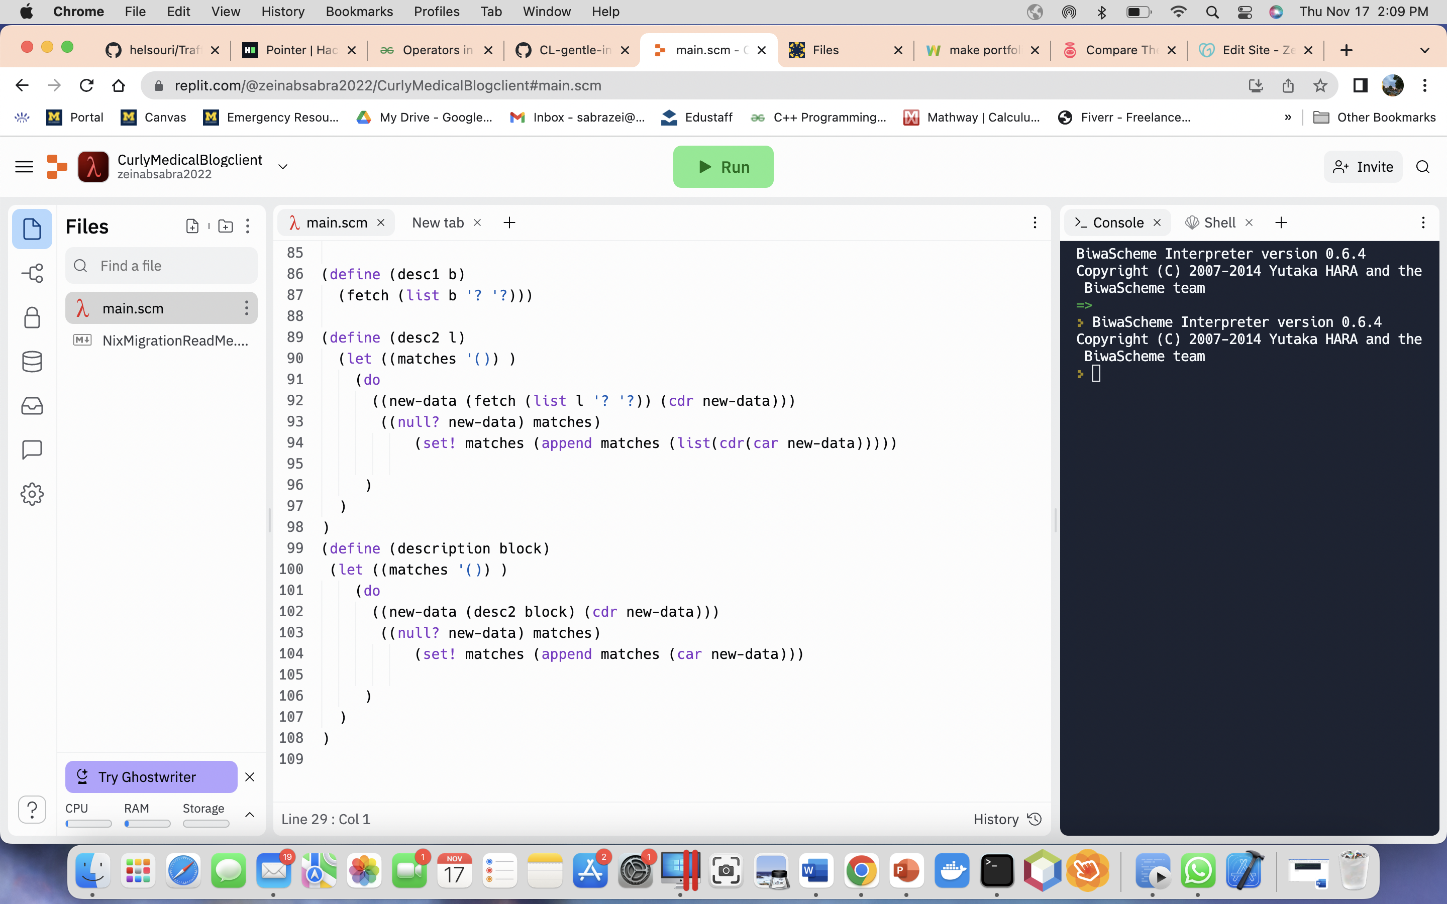

**Part b:**

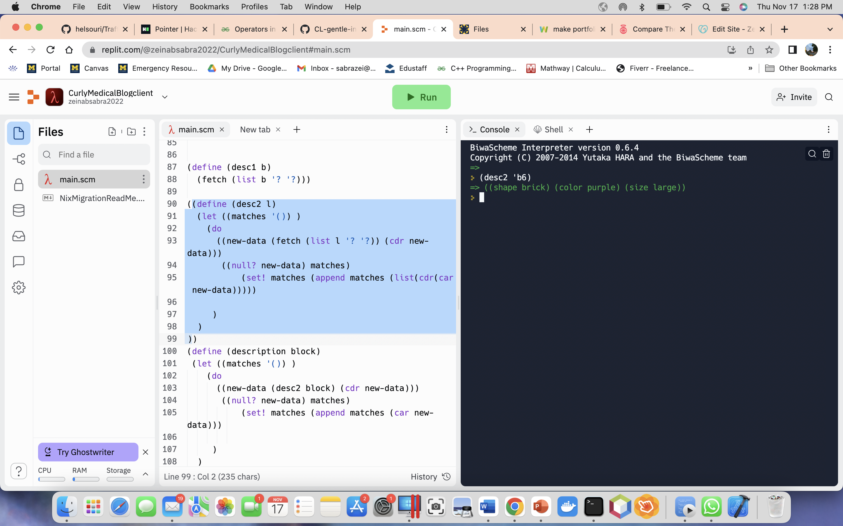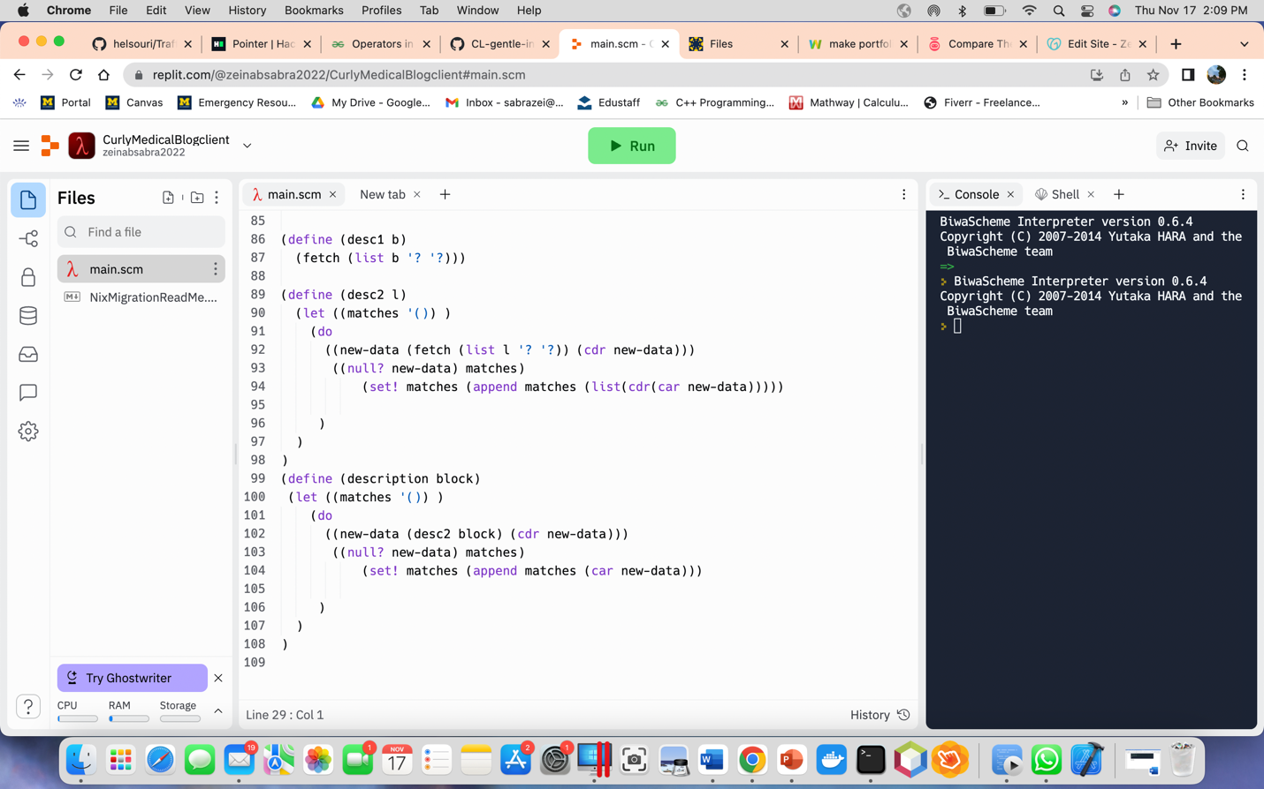

**Part C:**

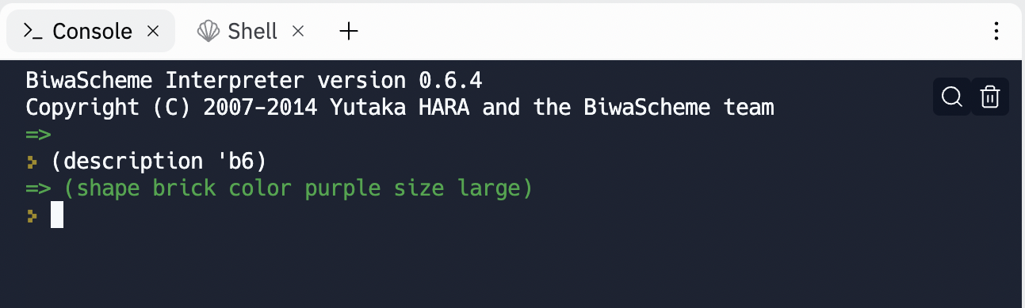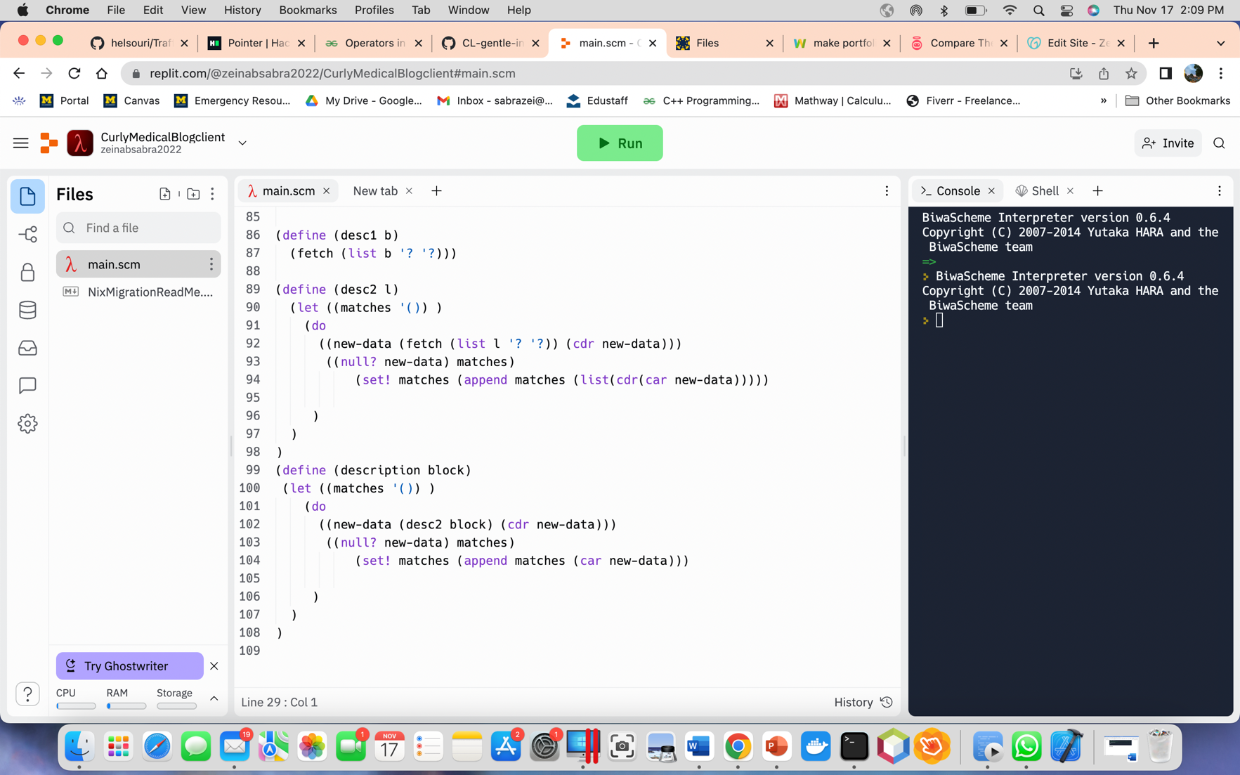

**Part D:**

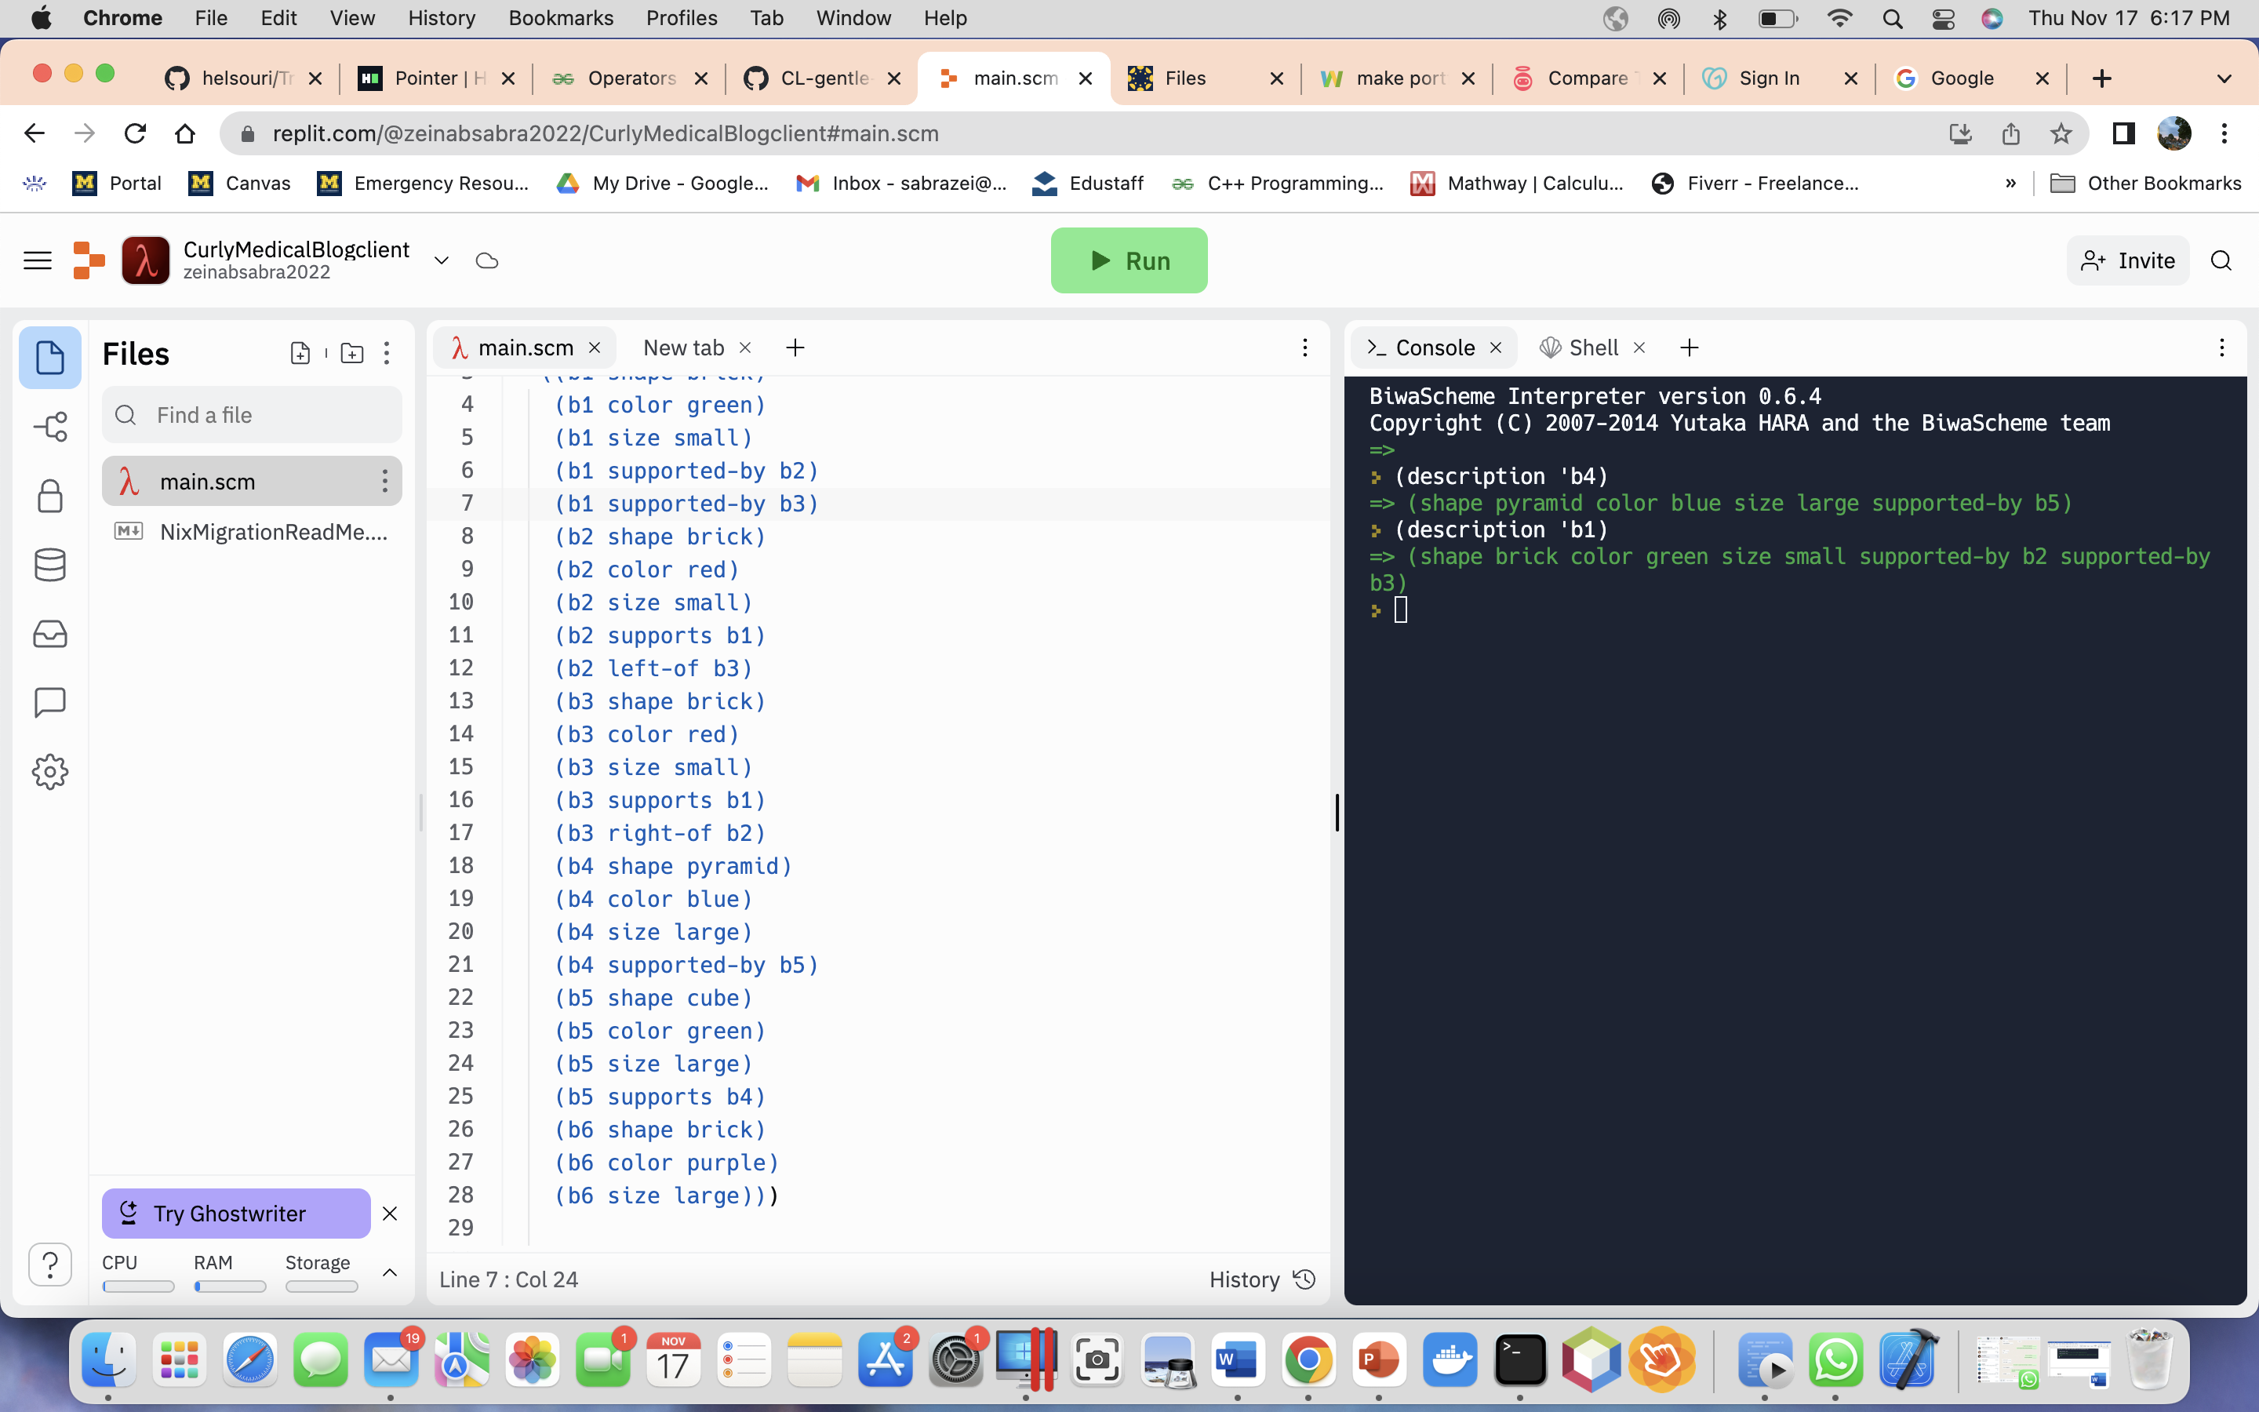

**Task 10:**

**Part a:**

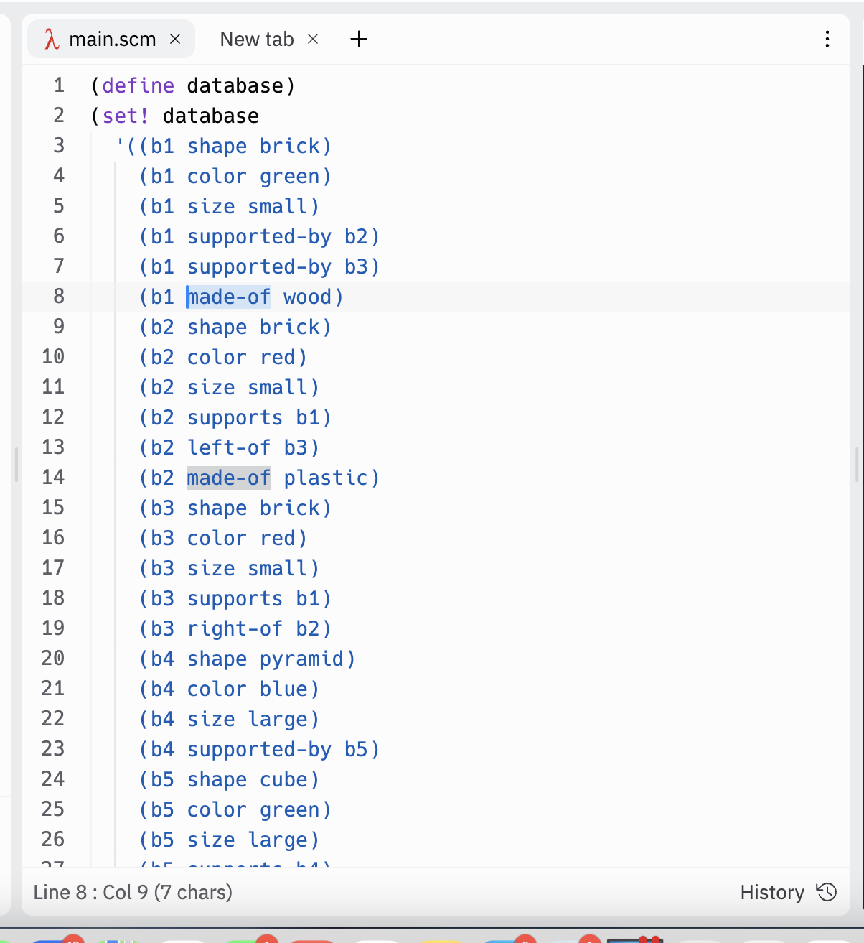

Part b:

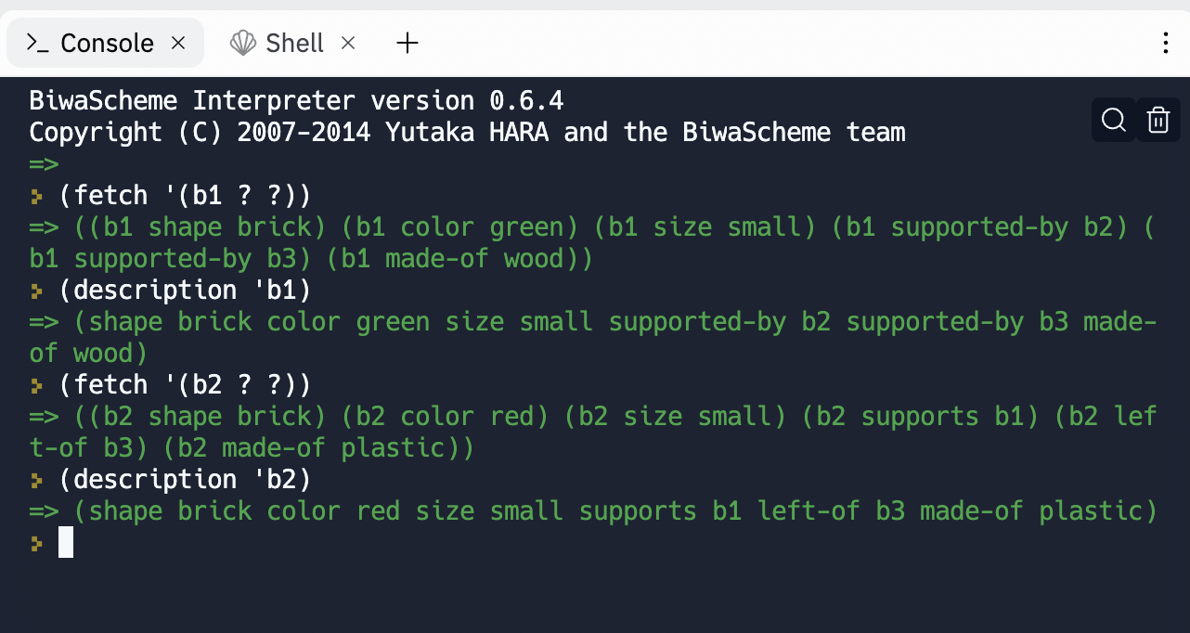

**Source Code:**

(define database)

(set! database

'((b1 shape brick)

(b1 color green)

(b1 size small)

(b1 supported-by b2)

(b1 supported-by b3)

(b1 made-of wood)

(b2 shape brick)

(b2 color red)

(b2 size small)

(b2 supports b1)

(b2 left-of b3)

(b2 made-of plastic)

(b3 shape brick)

(b3 color red)

(b3 size small)

(b3 supports b1)

(b3 right-of b2)

(b4 shape pyramid)

(b4 color blue)

(b4 size large)

(b4 supported-by b5)

(b5 shape cube)

(b5 color green)

(b5 size large)

(b5 supports b4)

(b6 shape brick)

(b6 color purple)

(b6 size large)))

(define (match-element s1 s2)

(or (equal? s1 s2) (equal? s2 '?))

)

(define (match-triple l1 l2)

(if

(and

(match-element (car l1) (car l2))

(match-element (cadr l1) (cadr l2))

(match-element (car(cdr(cdr l1))) (car(cdr(cdr l2))))

)

#t

#f

)

)

(define (fetch p)

(let ((matches '()) )

(do

((new-data database (cdr new-data)))

((null? new-data) matches)

(if (match-triple (car new-data) p)

(set! matches (append matches (list(car new-data))))

)

)

)

)

(define (color-pattern b)

(cons b '(color ?)))

(define (supporters b)

(let ((matches '()) )

(do

((new-data (fetch (list b 'supported-by '?)) (cdr new-data)))

((null? new-data) matches)

(set! matches (append matches (cdr(cdr(car new-data)))))

)

)

)

(define (supp-cube b)

(let ((matches (supporters b)))

(if (not (eqv? '() matches))

(if (not(eqv? '() (fetch (list (car matches) 'shape 'cube))))

#t

#f

)

#f

)

)

)

(define (desc1 b)

(fetch (list b '? '?)))

(define (desc2 l)

(let ((matches '()) )

(do

((new-data (fetch (list l '? '?)) (cdr new-data)))

((null? new-data) matches)

(set! matches (append matches (list(cdr(car new-data)))))

)

)

)

(define (description block)

(let ((matches '()) )

(do

((new-data (desc2 block) (cdr new-data)))

((null? new-data) matches)

(set! matches (append matches (car new-data)))

)

)

)